Lit. Surveys
Contents
Base etching 1
Characterization of SiO2 surface treatments using AFM, contact angles and a novel dewpoint technique 1
Permeable Silica Shell through Surface-Protected Etching 2
Hopper experiments 3
Enhancing the physical modeling capability of open-source MFIX-DEM software for handling particle size polydispersity: Implementation and validation 3
Guidelines for the CONTROL OF STATIC ELECTRICITY IN INDUSTRY ARCHIVE 5
Granular segregation in discharging cylindrical hoppers: A discrete element and experimental study 5
Fluidized-bed measurements of carefully-characterized, mildly-cohesive (Group A) particles 6
AFM 6
Cohesive Grains: Bridging Microlevel Measurements to Macrolevel Flow Behavior via Surface Roughness 6
Effect of roughness and shape factor on flotation characteristics of glass beads 8
Pull-off force measurements between rough surfaces by atomic force microscopy 10

Base etching

Characterization of SiO2 surface treatments using AFM, contact angles and a novel dewpoint technique
The surface roughness of glass( in this case microscope slides) was increased by acetic acid, heated NaOH and piranha etch. Used 12 M NaOH and 12 M KOH solutions in ID water. The heated NaOH echting was do for 30 min at 180 C. 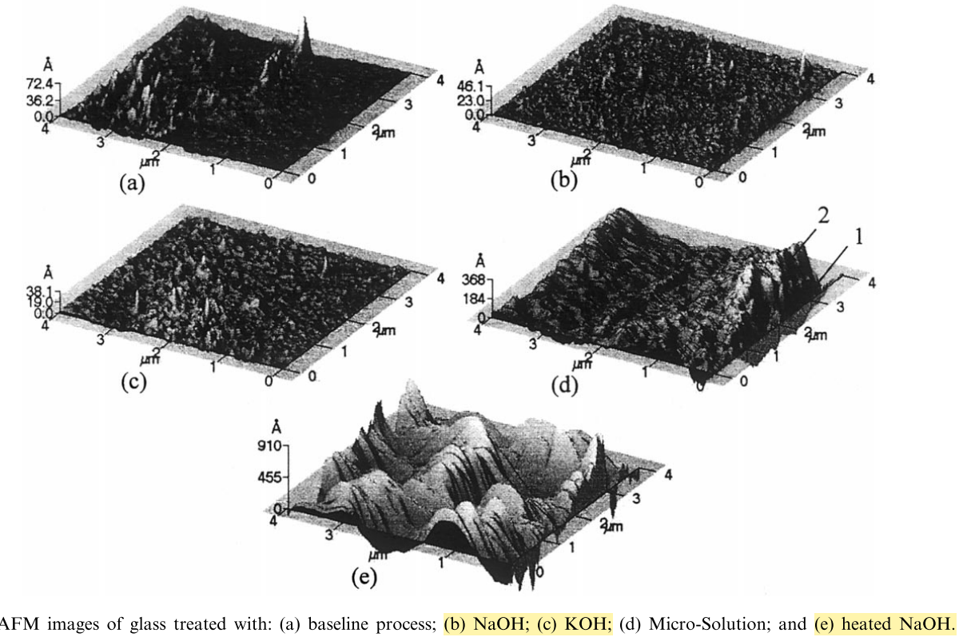
The above image is what the surface looked like from various base etchings. KOH showed the largest surface roughness for bases. NaOH and KOH reduced the surface roughness of glass. Heated Micro-Solution and heated NaOH treatment increased surface roughness. Heating can have a large impact on the effects on the surface. “KOH, NaOH[ solutions], and argon sputtering were found to smooth glass”

Permeable Silica Shell through Surface-Protected Etching
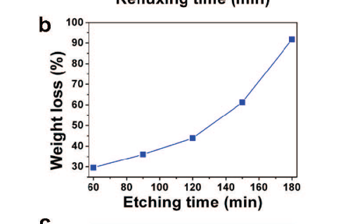
This is a graph comparing the weight (%) loss of SiO2 spheres that were coated with a PVP coating. The base etchant, NaOH etched the SiO2 spheres from the inside out. What I can gather is that etching time greater then 60min will seriously reduce the mass of the spheres. Please note that the sphere here had a protecting layer around it. From the experimental procedures they used 0.1 g NaOH/ 1 ml or 2.3 M solution of sodium hydroxide to perform the etching.

Hopper experiments

Enhancing the physical modeling capability of open-source MFIX-DEM software for handling particle size polydispersity: Implementation and validation
Used soda-lime silica glass beads that has a particle density of 2.5 g/cm³ “The fine particles possess a normal distribution with a mean of 1.5 mm and standard deviation of 0.3 mm, and the coarse particles possess a normal distribution with a mean of 2.9 mm and standard deviation of 0.1 mm” Dimensions of the hopper: cylinder height 12.5 cm, 12.5 cm diameter, cone height of 3.5 cm and 55° cone angle which is connected to a shot cylinder 1.3 cm in height and 2.5 cm in diameter. Used anti-static solution on beads, made by mixing 1ml of ASA anti-static agent into 100 mL of ethanol. No change in flow due to spray.
Used a discontinuous sampling method, where each sample was sieved for lard and fine particles and those where then weighed. Each experiment was ran five times. It was found that the fines tend to build up at the hopper bottom towards the end of the discharge.
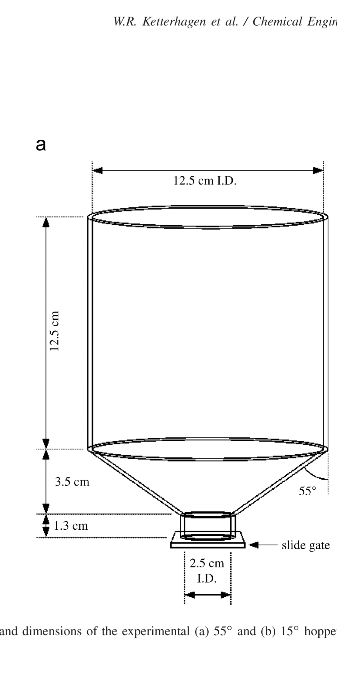

Guidelines for the CONTROL OF STATIC ELECTRICITY IN INDUSTRY ARCHIVE
Genera means to control static electricity. Bonding and earthing of stationary conductive equipment. Increasing the conductivity of nonconductors by incorporating conductive additives, surface layers and films and by humidification of the air. Ionizing the air. Try earthing the hopper to dissipate the static charge, do this by looking for a ground wire in the lab. Used something like what’s pictured below.
. 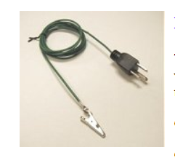

Granular segregation in discharging cylindrical hoppers: A discrete element and experimental study

Granular microstructure affected segregation of fine and course particles. Particle diameter ratio is the ratio of the diameter of the course particles to the diameter of the fine particles. Used soda lime glass beads (ρ=2.52 g/cm^3). The glass beads were relatively large and non-cohesive and have a large coefficient of restitution.
Fill methods
Three different kinds of filling methods used, layer fill, well mixed fill, and dual hopper fill. Layered fill is when an initial layer is placed down and then a second layer is placed carefully on top of the first one. Well-mixed fill is when the glass beads, course and fines, are mixed in a spinning riffler. The glass beads are then kneaded further by hand once they are placed into 16 plastic bags all having the same amount. These plastic bags are then carefully placed into the hopper and released in such a way as to minimize the distance the glass beads fall. Dual hopper fill is when a well-mixed charge is loaded into a 15-degree hopper and discharged into 55 degree hopper, this is the most industrial relevant because the hopper are usually fed from above themselves.
Discharge
Used a discontinuous discharging method. This way samples could be collected at different time intervals and there is little difference between continuous and discontinuous discharge patterns.
Computational models were underpredicting in terms of mass fraction of fine in discharge. Is might be due to non-sphericity of the particles and/or differences in material interaction coefficients.
The layered fill method is the easiest to repeat in real life and so it more likely that the experimental and computational data are close to each other.
Parameters that affect segregation of particles during discharge/internal flow are particle diameter ratio, fines mass fraction, hopper cross-sectional shape, hopper angle, fill method and characteristics of the material.

Fluidized-bed measurements of carefully-characterized, mildly-cohesive (Group A) particles
Status: incomplete
Sliding friction is equal to the static/kinetic frictional coefficient times the normal force applied to the object in question. Values for static/kinetic frictional coefficient for glasses such as soda lime and borosilicate, range from 0.1 to 0.3. A defluidization curve is the pressure drop vs. gas velocity. Coefficient of restitution significantly affects bubble properties but does not have a large impact on defluidization curve. In predicting van der Waals forces between particles, it is the normal direction that is critical. This is because it dictates the minimum separation distance between particles.
To fully characterize a group of particles the following properties of the particles must be determined.
- Coefficient of friction
- Shape(sphericity)
- Coefficient of restitution
- Surface roughness
For (2) an optical microscope was used to take images which is used to measure the sphericity which is the particle projected area diameter divided by the projected perimeter diameter. The following references will be useful.
C.Q. LaMarche, P. Liu, K.M. Kellogg, A.W. Weimer, C.M. Hrenya, A system-size independent validation of CFD-DEM for noncohesive particles, AIChE J. 61 (2015) 4051–4058, http://dx.doi.org/10.1002/aic.15057.
From the above source:
I. Cavarretta, C. O’Sullivan, M.R. Coop, Applying 2D shape analysis techniques to granular materials with 3D particle geometries, in: M. Nakagawa, S. Luding (Eds.), Powders and Grains 2009: Proceedings of the 6th internatIonal Conference on Micromechanics of Granular Media, Golden, CO, 2009, pp. 833–836, http://dx.doi.org/10.1063/1.3180057.
For (3) a glass bead of 2 mm is released from tweezers at a known height, h_{o} , and the bead is allowed to bounce on a flat surface, and the maximum height, h_{f} , of the beads rebound recorded using a high speed camera. The restitution coefficient (e) is the calculated using the following formula, $e= \sqrt{h_{f}/h_{o}}$.
Three size ranges where used, 20-38 µm, 45-53 µm, 63 – 75 µm.

Funnel Flow in Hoppers

AFM

Cohesive Grains: Bridging Microlevel Measurements to Macrolevel Flow Behavior via Surface Roughness
Van der Waals forces dictate the cohesion of fine particles. Increasing surface roughness of particle where van der waal forces play a large role in the magnitude of cohesion forces, decrease the cohesion forces. $van der waal forces ∝ \frac{1}{{\left(separation distance \right)}^{2}}$
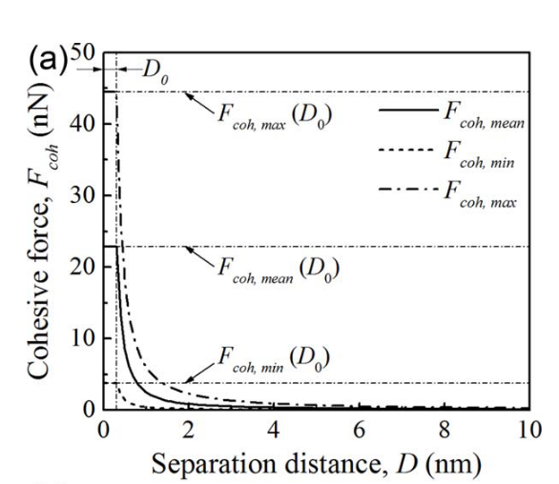
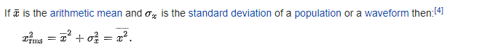
To reduce electrostatic in the fluidized bed column, they grounded the column and used an antistatic spray. They reported no signs of electrostatics.
The glass beads they used were soda lime glass and had a diameter of 69 µm and a density of 2500 kg/m^3. They are classified as Geldart Group A particles. 6 kg of glass beads were used in the experiment.

Effect of roughness and shape factor on flotation characteristics of glass beads
Status: complete, 3/26/19, note: will review in the future
AFM machine and tip used to characterize the roughness of glass beads:
”Surface morphology and roughness of the samples were determined by a Park System XE-70 Atomic Force Microscope (AFM) in non-contact mode. The non-contact cantilever Mikromasch NSC- 15 purchased from Park System Co., was used.”
Product details of the NSC -15 tip:
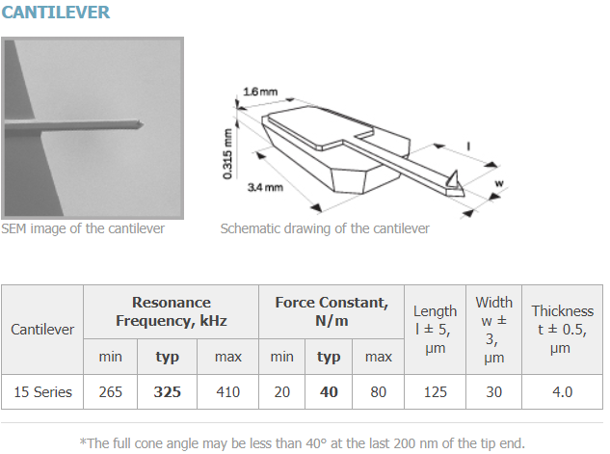

Here is how I will plot my roughness values aka my Ra and Rq values:
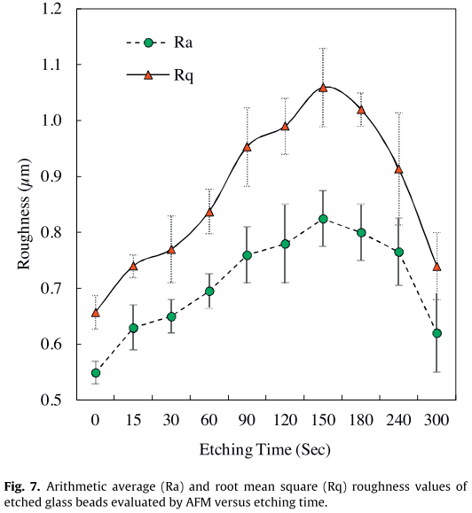
Since they worked with spheres that were small they applied a method to cancel out the error introduced from the geometry of the sphere. Did it as follows:
“Since the spherical particles of around 100 um are used in this study, the contact-mode topography method of AFM was found inappropriate for roughness measurements. Variations in the height of the Z-stage of the AFM due to the shape of the sample can affect the results. In this method, roughness of even an atomically smooth sphere will be reported unequal to zero as the mean line will be determined based on the particle shape itself (Fig. 4). “
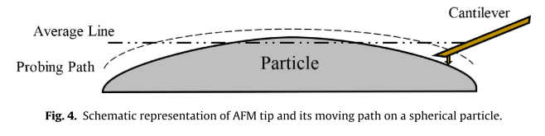

Pull-off force measurements between rough surfaces by atomic force microscopy
Status: complete, 12/13/18
Gives explanation of pull off (adhesion) forces measured by AFM of different surfaces with different roughness’s. Not to relevant but could be if I start using AFM. The particles studied have surface geometry’s that require the use of different models (explained in the paper) explain the roughness quantitively. They used model to models the geometry and tried to then predict the pull off forces and these models did not correlate very well to actual experimental values, which was probably due to irregular geometry of the particles and particle deformation.

Adhesion forces between glass and silicon surfaces in air studied by AFM: Effects of relative humidity, particle size, roughness and surface treatment.

